**INSTAGRAM REACH**

**ANALYSIS USING**

**PYTHON**

## 

## 

## ABSTARACT

Social media platforms like Instagram are vital for personal branding, marketing, and audience engagement in the digital age. Understanding audience reach and engagement is crucial for optimizing content strategies and improving overall performance. This project focuses on analyzing Instagram reach using Python to uncover insights and patterns in user engagement.

The project utilizes Python's powerful data analysis and visualization libraries, including **Pandas**, **Numpy**, **Matplotlib**, and **Sea born**, to process and analyze Instagram data such as likes, comments, impressions, and follower growth. Key metrics, such as engagement rates and reach trends, are computed to evaluate content effectiveness.

Advanced techniques, such as sentiment analysis of captions using **NLTK** or **Text Blob**, and audience behaviour clustering with **scikit-learn**, may be incorporated to provide a deeper understanding of user interactions. The project also explores predictive analytics using regression models to forecast reach and engagement for future posts.

By the end of this project, stakeholders will have actionable insights into audience preferences, peak activity times, and optimal content strategies, empowering them to enhance their Instagram presence. This analysis not only assists individuals and influencers but also supports businesses in achieving better ROI for their marketing efforts on Instagram.

## INTRODUCTION

Instagram has become a leading platform for social engagement, offering individuals, influencers, and businesses a powerful tool to connect with audiences worldwide. Understanding how content performs on this platform is essential for improving reach, engagement, and overall impact. Instagram reach, which measures the number of unique users exposed to a piece of content, serves as a key indicator of visibility and audience penetration. Analyzing this metric, alongside related engagement data, provides valuable insights for optimizing content strategies and achieving social media goals.

This project involves using Python to analyze Instagram reach and engagement data, focusing on trends, user behavior, and performance metrics. Python's ecosystem of data analysis libraries, such as **Pandas**, **Numpy**, and **Matplotlib**, offers robust tools for data cleaning, manipulation, and visualization. Additionally, advanced libraries like **Sea born** and **Plotly** enable interactive and in-depth visual storytelling.



Online communities exist on a variety of platforms, including social media, forums, and messaging apps. Understanding reactions across diverse platforms can be challenging due to the differences in user demographics, communication styles, and moderation policies. The rapid spread of information, both accurate and inaccurate, on social media platforms poses challenges for researchers.

Distinguishing between reliable information and misinformation during global events is crucial. Algorithms used by social media platforms can amplify certain types of content, potentially influencing the direction of online discussions. Understanding the role of algorithms in shaping community reactions is an ongoing area of research. Ethical considerations and privacy concerns may limit researchers’ access to certain data, impacting their ability to study online community reactions comprehensively.

## Do personalized instagram hashtag research to grow organically

Hash tags are keywords or phrases which are used to reference a topic or theme. A hash tag consists of a hash (#) symbol followed by the text. They are used to indicate what some information is related to. This allows users to find, share and react to information on a certain topic or theme easily by searching for the relevant hash tag. Hash tags are a popular part of social media platforms. As multiple hash tags can be used at once, we can track the relations between specific hash tags. These relations can then be graphed and analyzed to see how people connect different topics and themes.

Social Media is widespread with 59% of the global population using many different platforms[5](https://nhsjs.com/2024/how-hashtags-are-used-on-instagram-following-a-globally-known-event-and-their-relevance/#footnote_4_11480). This provides researchers with a large dataset – one of the largest in the world – to analyze people’s thoughts and emotions towards global events[6](https://nhsjs.com/2024/how-hashtags-are-used-on-instagram-following-a-globally-known-event-and-their-relevance/#footnote_5_11480) – events which are known by the public on a large scale such as political decisions in powerful countries, a major event in a celebrity’s life or military action.



Instagram is one of the biggest social media platforms. The platform has over 500 million DAUs (daily active users) and 2.35 billion MAUs (monthly active users)[7](https://nhsjs.com/2024/how-hashtags-are-used-on-instagram-following-a-globally-known-event-and-their-relevance/#footnote_6_11480). Being one of the most popular social media platforms, Instagram’s wide use of hash tags provides a vast amount of information to be analyzed and several different insights.

Through social media platforms, people – the users – share their opinions. These opinions show the thoughts of the person as well as their views on topics. As the community interacts, the information shared is an active representation of the thoughts, points of view and feelings of the users. Engagement within the community facilitates an efficient analysis of how a community reacts to information on a certain topic or theme.



Key goals include identifying optimal posting times, understanding which content resonates most with the target audience, and detecting patterns in audience engagement. Advanced techniques like trend forecasting and clustering may be applied to predict future reach and segment user behavior effectively.

By integrating data-driven strategies into content planning, this analysis empowers users to navigate Instagram’s dynamic landscape more effectively, fostering growth and deeper connections with their audience. Whether for personal branding, influencer marketing, or business promotion, the insights from this project aim to enhance Instagram strategies and outcomes.

##### METHODS OF DATA ANALYSIS

To analyze Instagram reach effectively, a structured methodology is essential. The following steps outline how Python can be used to gather, process, and extract insights from Instagram data:

#### **1. Data Collection:**

* **Instagram API**: Use the Instagram Graph API to fetch data such as reach, impressions, follower demographics, and engagement metrics (likes, comments, shares, saves).
* **CSV/Excel Data Import**: Extract data from third-party analytics tools like Hoot suite, Buffer, or Instagram Insights as CSV or Excel files.
* **Web Scraping**: Employ libraries like **Beautiful Soup** or **Selenium** to scrape publicly available Instagram data if APIs or exports are unavailable.

**2. Data Preprocessing**

* **Cleaning the Data**:
  + Handle missing values using libraries like **Pandas** (fillna() or dropna() methods).
  + Remove duplicate entries and irrelevant columns.
* **Data Formatting**:
  + Convert date and time fields to Python date time objects for time-based analysis.
  + Standardize metrics like likes, comments, and reach into consistent formats.
* **Feature Engineering**:
  + Create new metrics, such as engagement rate ((likes + comments)/followers * 100) or reach-to-impressions ratio.

#### **3. Exploratory Data Analysis (EDA)**

* **Descriptive Statistics**:
  + Use **Pandas** and **Numpy** to calculate metrics such as mean, median, and variance for reach, impressions, and engagement.
* **Data Visualization**:
  + Employ **Matplotlib** and **Seaborn** to visualize trends and distributions:
    - Line plots for tracking reach over time.
    - Heat maps to identify peak engagement times.
    - Bar charts for top-performing content types.

#### **4. Time-Series Analysis**

* Analyze how reach and engagement vary over time using **stats models** or **Prophet** Libraries.
* Identify trends, seasonality, and anomalies in posting schedules and audience interactions.

**5. Sentiment Analysis**

* Analyze captions or comments using **Text Blob** or **NLTK** to understand audience sentiment and its impact on reach.

#### **6. Correlation Analysis**

* Use **Pandas** (.corr()) and **Seaborn heat maps** to study relationships between variables:
  + Does posting time correlate with higher reach?
  + How do hash tags or content types affect impressions?

#### **7. Clustering and Segmentation**

* Apply clustering algorithms from **scikit-learn** to group content or audience behavior patterns based on metrics like reach, impressions, and engagement rates.

**8. Predictive Analytics**

* Use machine learning models to forecast future reach or engagement:
  + Regression models to predict reach based on posting time, hashtags, or content type.
  + Classification models to determine the likelihood of a post achieving high engagement.

#### **9. Insights and Recommendations**

* Generate actionable insights from the analysis, such as:
  + Optimal posting times and days.
  + Best-performing content types (e.g., reels, carousel posts).
  + Effective hash tags and caption strategies.
* Summarize findings using interactive dashboards with **Plotly Dash** or **Streamlit**.

By following these methods, Instagram reach analysis using Python can uncover valuable insights that help users refine their strategies, improve engagement, and maximize visibility on the platform.

**FEASIBILITY STUDY**

## FEASIBILITY STUDY

## A feasibility study assesses the practicality of executing Instagram reach analysis using Python, focusing on technical, operational, economic, and legal aspects. This ensures the project is realistic and provides value to stakeholders.

#### **1. Technical Feasibility:**

**Required Resources and Tools**

* **Python Libraries**:
  + **Pandas** and **Numpy** for data processing and analysis.
  + **Matplotlib**, **Seaborn**, and **Plotly** for data visualization.
  + **Scikit-learn** for machine learning tasks.
  + **Text Blob** or **NLTK** for sentiment analysis.

**2. Operational Feasibility:**

**Skill Requirements**

* Data analysts or developers need proficiency in Python, data analysis libraries, and API integration.
* Basic understanding of social media metrics and strategies is beneficial.

#### **3. Economic Feasibility:**

**Cost Factors**

* **Software Costs**: Python is open-source, reducing costs significantly.
* **Data Costs**: Tools for data export or API integration might have subscription fees.
* **Infrastructure**: Minimal costs if run on existing hardware; moderate costs for cloud-based solutions.

#### **4. Legal and Ethical Feasibility:**

**Data Privacy and Compliance**

* Instagram’s API has strict terms of use to ensure data privacy. Adherence to these terms is mandatory.
* Avoid scraping private or sensitive data to comply with data protection regulations (e.g., GDPR, CCPA).

**Ethical Considerations**

* Data analysis should focus on insights for optimization, avoiding misuse of audience information.
* Maintain transparency with clients or stakeholders regarding the nature and purpose of data analysis.

#### **5. Timeline Feasibility:**

**Estimated Timeframe**

* **Data Collection and Preparation.**
* **Exploratory Data Analysis (EDA)**.
* **Visualization and Modeling**.
* **Insight Generation and Reporting**.

Conducting Instagram reach analysis using Python is technically, operationally, and economically feasible. With proper legal compliance and skilled execution, the project can deliver valuable insights, making it a practical and impactful initiative.

# REQUIRMENT

# SPECIFICATIONS

## REQUIRMENT SPECIFICATIONS

#### **1. Functional Requirements:**

1. **Data Collection**
   * **Instagram API Integration**:  
     The system must be able to access Instagram's Graph API to retrieve metrics such as reach, impressions, likes, comments, saves, follower demographics, and post metadata.
     + Required API endpoints: /media, /insights, /users, etc.
     + User authentication via Oath tokens to access private data (for business accounts).
   * **CSV/Excel Imports**:  
     Ability to import Instagram analytics data in CSV or Excel format from third-party tools like Hoot suite or Buffer for offline analysis.
   * **Web Scraping (Optional):**For accounts without API access, the system should be capable of scraping public posts, captions, and engagement metrics using Python libraries like **Beautiful Soup** or **Selenium**.

#### **2. Non-Functional Requirements:**

1. **Performance**
   * The system should handle data from multiple Instagram accounts without significant delays or crashes, especially when dealing with large datasets (e.g., multiple months or years of data).
   * Data processing should be optimized for efficiency, with techniques like chunking and parallel processing for large-scale datasets.
2. **Scalability**
   * The solution should be scalable to handle increasing volumes of data, including handling multiple user accounts and potentially large datasets (millions of posts over extended periods).
   * The system should allow for easy integration of additional data sources in the future.
3. **Security and Privacy**
   * Authentication to the Instagram API should be secure, using OAuth tokens, to protect user data.
   * The system must comply with data protection laws such as GDPR and CCPA, ensuring user privacy and confidentiality in all analyses.
4. **Usability**
   * The system should be user-friendly, with clear instructions on importing data, selecting analysis methods, and generating reports.
   * Visualizations should be intuitive and provide actionable insights.
5. **Documentation**
   * Comprehensive documentation is required, including setup instructions, data input/output formats, and usage guidelines.
   * The code should be well-commented and maintainable for future updates or modifications.

#### **3. Technical Requirements:**

1. **Programming Language**
   * Python 3.x or higher should be used as the primary language for data processing, analysis, and modeling.
2. **Libraries and Tools**
   * **Pandas**: For data manipulation and processing.
   * **Numpy**: For numerical operations.
   * **Matplotlib** and **Seaborn**: For data visualization.
   * **Plotly** or **Stream lit**: For creating interactive dashboards.
   * **Scikit-learn**: For machine learning tasks, such as clustering and regression.
   * **Text Blob** or **NLTK**: For sentiment analysis of captions or comments.
   * **Requests**: For making API requests to Instagram’s Graph API.
   * **Beautiful Soup** or **Selenium**: For web scraping if needed.

# SYSTEM ANALYSIS

## SYSTEM ANALYSIS

System analysis for Instagram Reach Analysis involves understanding the requirements, design considerations, and operational flow of the system. It focuses on ensuring that the system can collect process, analyze, and present Instagram data to help users derive valuable insights into their reach, engagement, and content performance.

#### **1. System Overview**

The Instagram Reach Analysis system is designed to track and analyze the performance of Instagram accounts, focusing on key metrics such as reach, impressions, likes, comments, shares, and engagement rates. By utilizing Python libraries and APIs, this system will process Instagram data, perform statistical analysis, and generate actionable insights for content creators, businesses, and marketers.

**Key Goals**:

* Retrieve Instagram data for performance tracking.
* Analyze engagement, reach, and other key metrics.
* Generate reports and interactive dashboards to visualize the insights.

#### **2. Data Flow and Process Flow**

The system follows a structured data flow to ensure smooth collection, processing, and analysis. Each stage is essential for ensuring the system provides accurate and insightful results.

**Data Collection**

* **Instagram Graph API**: The system retrieves data such as reach, impressions, likes, comments, follower demographics, and engagement using Instagram’s **Graph API.**
* **CSV/Excel Import**: For users without API access, the system allows importing data in CSV or Excel formats, typically exported from third-party tools.
* **Web Scraping (Optional)**: In the absence of API access, Python’s Beautiful Soup or Selenium libraries can be used to scrape publicly available Instagram data.

#### **3. System Requirements**

The system must meet certain hardware, software, and technical requirements to function effectively and deliver optimal performance.

1. **Hardware Requirements**
   * **Basic Requirements**: A computer with a modern processor (Intel i5 or equivalent) and at least 8GB of RAM.
   * **Cloud Solutions**: If dealing with large datasets, the system can be hosted on cloud platforms like Google Colab, AWS, or Azure to scale computational resources as needed.
2. **Software Requirements**
   * **Programming Language**: Python 3.x or higher.
   * **Libraries**: Pandas, NumPy, Matplotlib, Seaborn, Plotly, scikit-learn, Text Blob, NLTK, Beautiful Soup, and Requests for API calls.
   * **IDE**: Development can be done using PyCharm, VSCode, or Jupiter Notebooks for an interactive coding environment.

**4. System Constraints**

Several constraints must be taken into account to ensure the successful implementation of the system:

1. **API Limitations**: Instagram’s Graph API has rate limits, which may restrict the frequency and amount of data retrieval.
2. **Data Accuracy**: Data exported from third-party tools may contain inaccuracies, which can affect analysis.
3. **Real-Time Processing**: The system may not perform real-time analysis, as data extraction and processing could take time depending on the dataset size.
4. **Legal Constraints**: The system must adhere to Instagram’s terms of service and privacy policies to ensure compliance with data protection laws such as GDPR and CCPA.

#### **5. System Use Cases**

1. **Content Creators**:  
   Content creators can use the system to monitor their post performance, determine the best times to post, and analyze engagement metrics to improve content strategies.
2. **Social Media Managers**:  
   Social media managers can use insights from the system to optimize content calendars, create targeted campaigns, and increase overall reach and engagement.
3. **Businesses and Marketers**:  
   Businesses can track their Instagram performance, identify the most engaging content, and adjust marketing strategies to maximize return on investment (ROI).

By conducting a thorough system analysis of Python with machine learning projects, stakeholders can ensure alignment with business objectives, mitigate risks, and maximize the value delivered by machine learning solutions.A thorough system analysis will contribute to the successful development and implementation of a train accident analysis system, fostering enhanced safety and efficiency in railway operations.Top of Form

# IMPLEMENTATION

### IMPLEMENTATION

Analyzing Instagram reach involves studying metrics such as engagement, likes, comments, followers, and impressions over time. Using Python, we can perform such analyses by leveraging tools like **Pandas** for data manipulation, **Matplotlib/Sea born** for visualization, and **Numpy** for computations. Below is a high-level approach to implement an Instagram reach analysis project:

### ****1. Collecting Instagram Data****

Data can be collected from:

* **Instagram Insights API**: Use the Instagram Graph API to fetch data programmatically.
* **Manual Export**: Export data from Instagram Insights (business accounts allow CSV exports).
* **Dummy Data**: If API access is unavailable, create a mock dataset.

### ****2. Tools and Libraries****

Install the required libraries:

pip install pandas numpy matplotlib sea born

### ****3. Implementation****

Here's a Python script for Instagram reach analysis using a sample dataset:

**Step 1: Import Libraries**

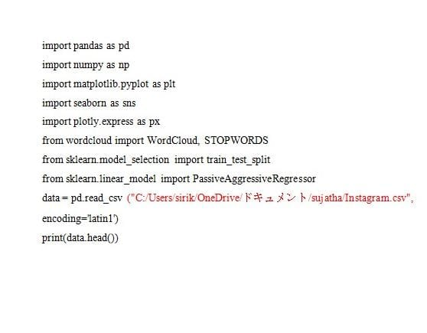

**OUTPUT:**

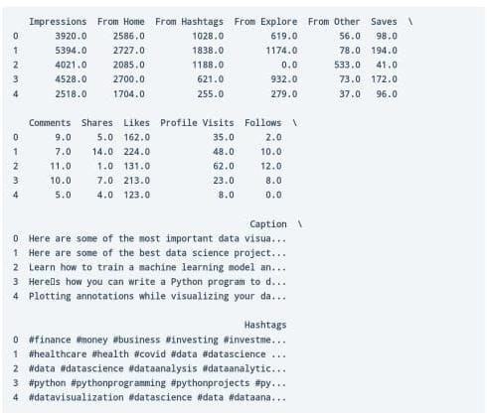

Before starting everything, let’s have a look at whether this dataset contains any null values or not:

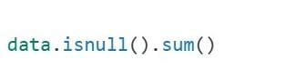   
**Output:**

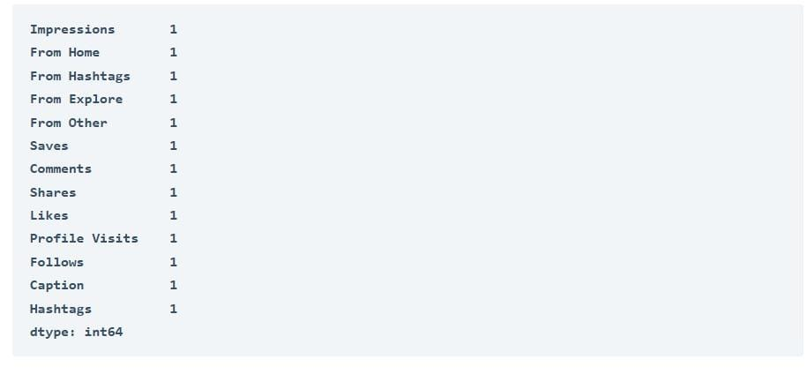

So it has a null value in every column. Let’s drop all these null values and move further:

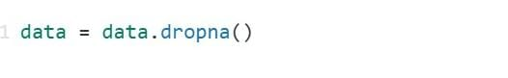

Let’s have a look at the insights of the columns to understand the data type of all the columns:

**2d1485e1-f611-47cb-87b4-6f8d83803ce5.jpeg**

**Output:**

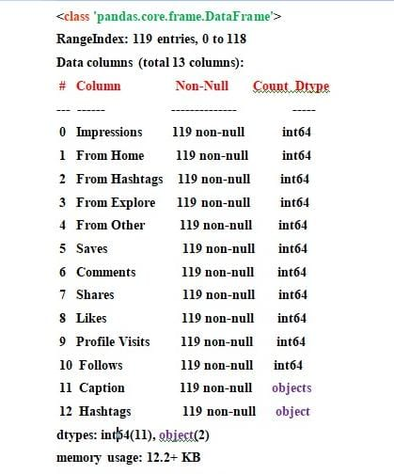

#### **Analyzing Instagram Reach**

Now let’s start with analyzing the reach of my Instagram posts. I will first have a look at the distribution of impressions I have received from home:

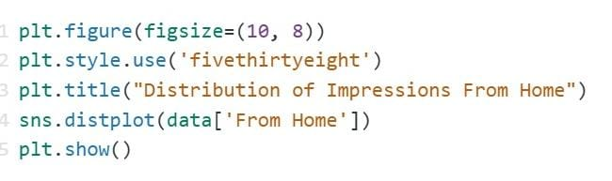

**Output:**

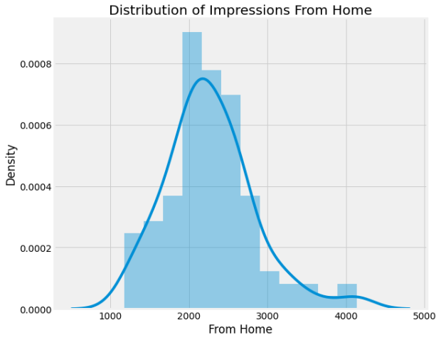

The impressions I get from the home section on Instagram shows how much my posts reach my followers. Looking at the impressions from home, I can say it’s hard to reach all my followers daily. Now let’s have a look at the distribution of the impressions I received from hash tags:

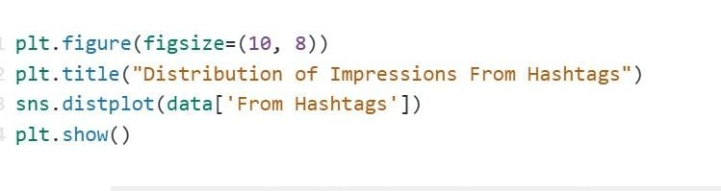

**Output:**

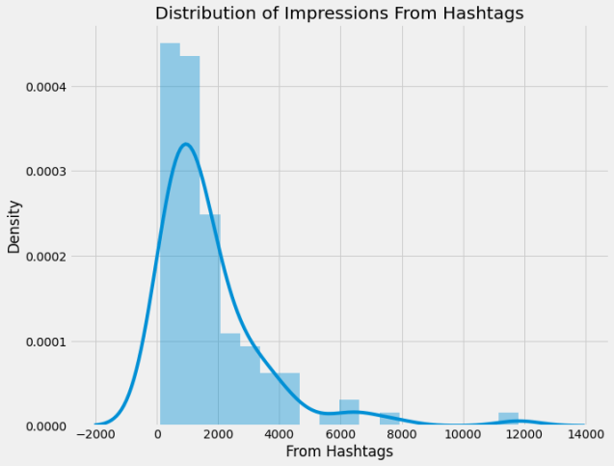

Hashtags are tools we use to categorize our posts on Instagram so that we can reach more people based on the kind of content we are creating. Looking at hash tag impressions shows that not all posts can be reached using hash tags, but many new users can be reached from hash tags. Now let’s have a look at the distribution of impressions I have received from the explore section of Instagram:

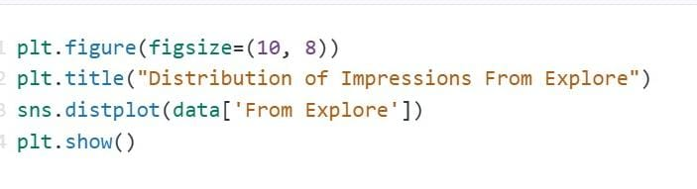

**Output:**

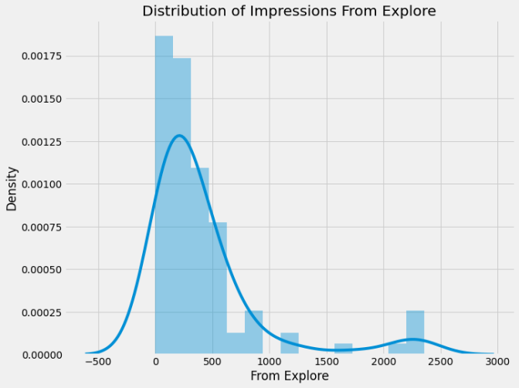

The explore section of Instagram is the recommendation system of Instagram. It recommends posts to the users based on their preferences and interests. By looking at the impressions I have received from the explore section; I can say that Instagram does not recommend our posts much to the users. Some posts have received a good reach from the explore section, but it’s still very low compared to the reach I receive from hash tags.

Now let’s have a look at the percentage of impressions I get from various sources on Instagram:

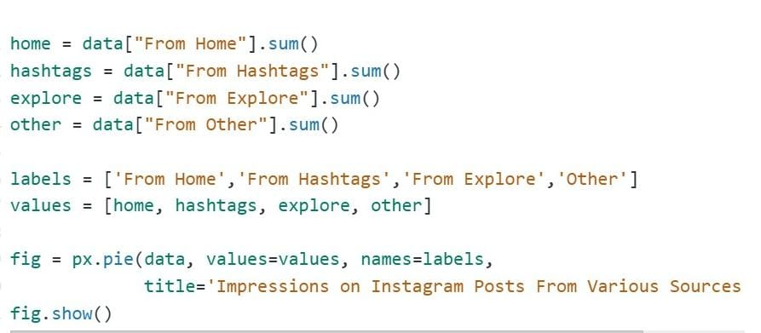

**Output:**

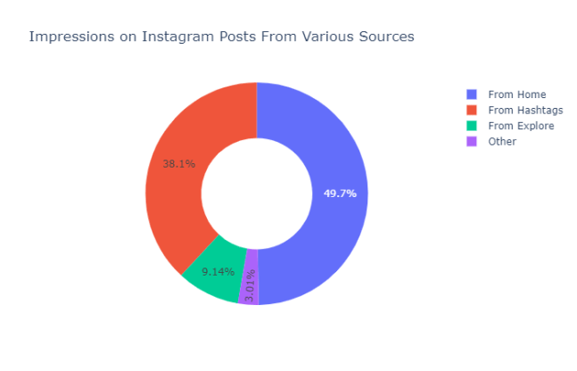

So the above donut plot shows that almost 50 per cent of the reach is from my followers, 38.1 per cent is from hash tags, 9.14 per cent is from the explore section, and 3.01 per cent is from other sources.

#### **Analyzing Content**

Now let’s analyze the content of my Instagram posts. The dataset has two columns, namely caption and hash tags, which will help us understand the kind of content I post on Instagram.

Let’s create a word cloud of the caption column to look at the most used words in the

Caption of my Instagram posts:

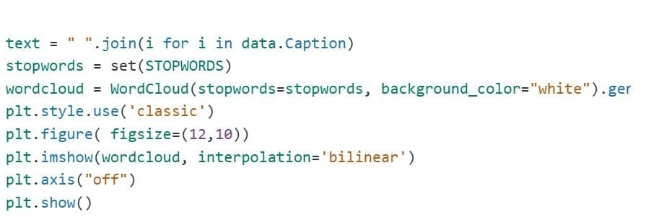

**Output:**

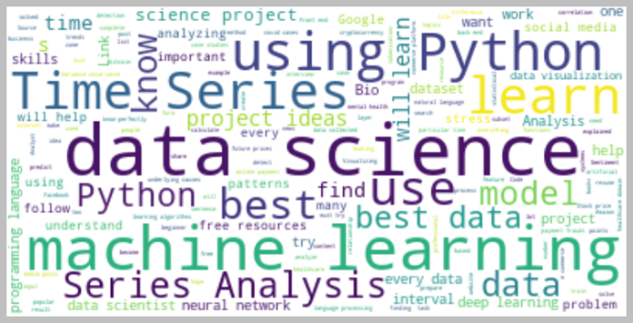

Now let’s create a word cloud of the hash tags column to look at the most used hash tags in my Instagram posts:

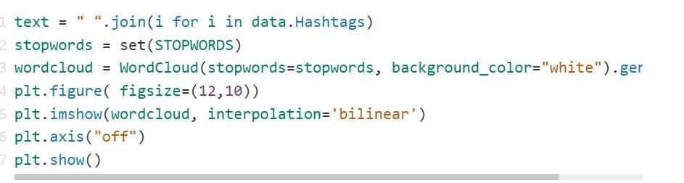

**Output:**

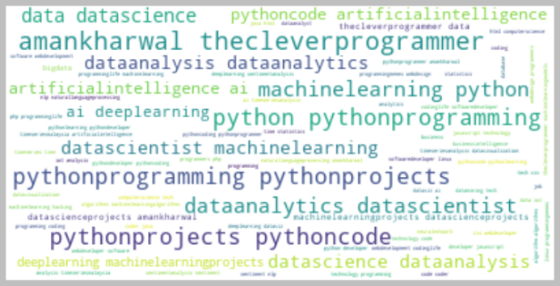

#### **Analyzing Relationships**

Now let’s analyze relationships to find the most important factors of our Instagram reach. It will also help us in understanding how the Instagram algorithm works.

Let’s have a look at the relationship between the number of likes and the number of impressions on my Instagram posts:

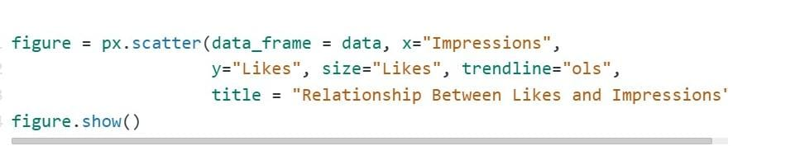

**Output:**

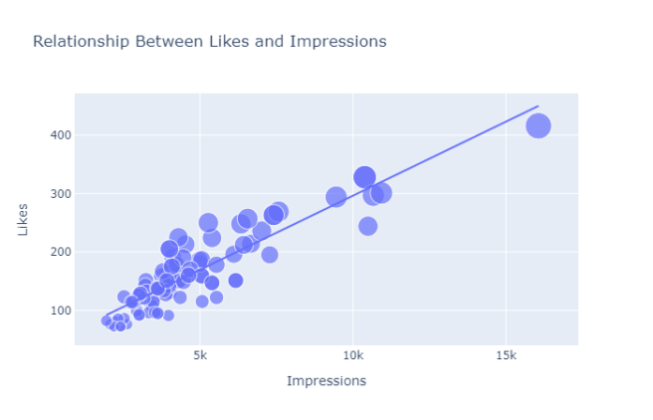

There is a linear relationship between the number of likes and the reach I got on Instagram. Now let’s see the relationship between the number of comments and the number of impressions on my Instagram posts:

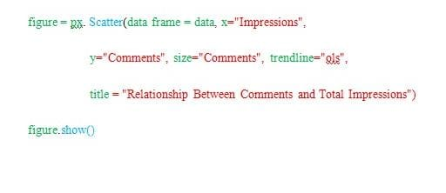

**Output:**

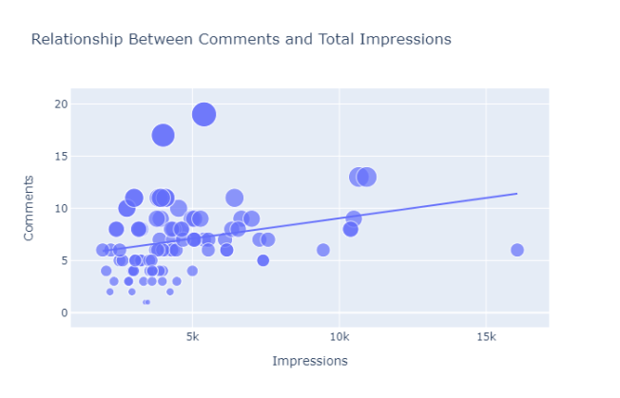

It looks like the number of comments we get on a post doesn’t affect its reach. Now let’s have a look at the relationship between the number of shares and the number of impressions:

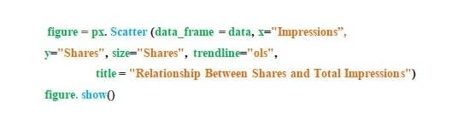

**Output:**

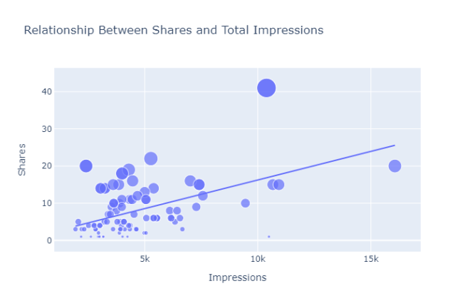

A more number of shares will result in a higher reach, but shares don’t affect the reach of a post as much as likes do. Now let’s have a look at the relationship between the number of saves and the number of impressions

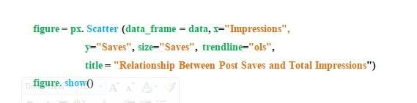

**Output:**

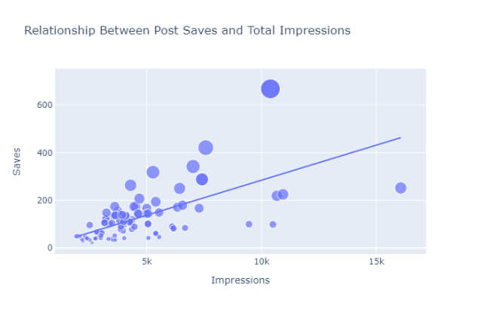

There is a linear relationship between the number of times my post is saved and the reach of my Instagram post. Now let’s have a look at the correlation of all the columns with the Impressions column:

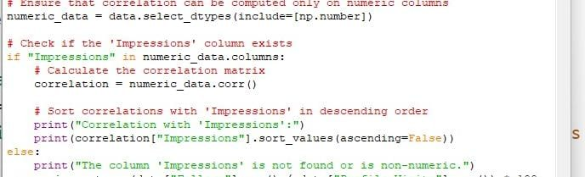

**Output:**

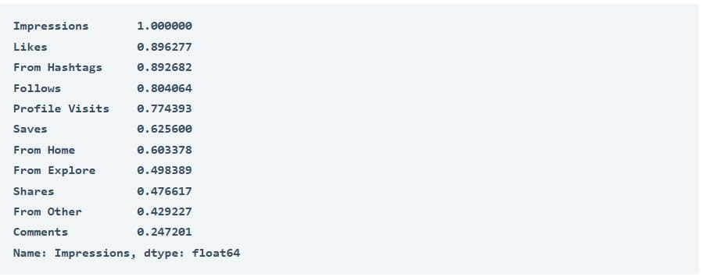

So we can say that more likes and saves will help you get more reach on Instagram. The higher number of shares will also help you get more reach, but a low number of shares will not affect your reach either.

#### **Analyzing Conversion Rate**

#### In Instagram, conversation rate means how many followers you are getting from the number of profile visits from a post. The formula that you can use to calculate conversion rate is **(Follows/Profile Visits) * 100**. Now let’s have a look at the conversation rate of my Instagram account:

#### 9fb1d21c-70a2-4216-b819-2b35f9c7e1ad.jpeg

#### **Output:**

#### **52d58119-7b3d-4892-a700-f266a3762894.jpeg**

#### So the conversation rate of my Instagram account is 31% which sounds like a very good conversation rate. Let’s have a look at the relationship between the total profile visits and the number of followers gained from all profile visits:

#### 12815c7c-cddb-4d26-b508-70be1ce223a4.jpeg

#### **Output:**

#### Instagram reach analysis: Relationship Between Profile Visits and Followers Gained

The relationship between profile visits and followers gained is also linear.

### Instagram Reach Prediction Model

Now in this section, I will train a machine learning model to predict the reach of an Instagram post. Let’s split the data into training and test sets before training the model:

Now here’s is how we can train a machine learning model to predict the reach of an Instagram post using Python:

Output

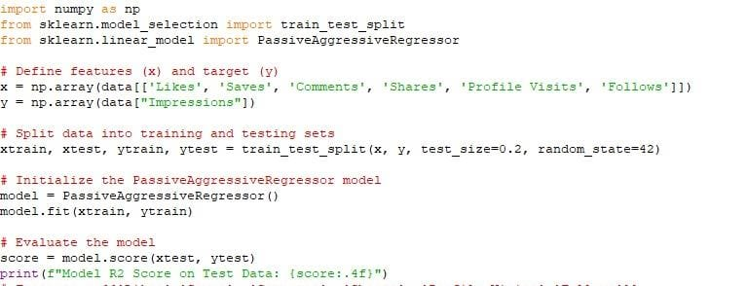

**Output:**

**95ce6f9d-a68d-42fc-b320-c74a38af48a9.jpeg**

Now let’s predict the reach of an Instagram post by giving inputs to the machine learning model:

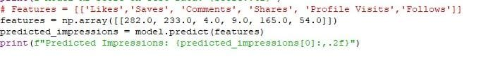

**Output:**

**832610a5-b80b-4ee5-89b3-34b75f8eaf1b.jpeg**

So this is how you can analyze and predict the reach of Instagram posts with machine learning using Python. If a content creator wants to do well on Instagram in a long run, they have to look at the data of their Instagram reach. That is where the use of Data Science in social media comes in. I hope you liked this article on the task of Instagram Reach Analysis using Python. Feel free to ask valuable questions in the comments section below.

# CONCLUSION

## CONCLUSION

The **Instagram Reach Analysis project** provides valuable insights into the factors influencing audience engagement, post performance, and overall content strategy. Here are the key takeaways:

**1. Improved Understanding of Metrics**  
by analyzing metrics like **reach**, **impressions**, **likes**, **comments**, and **engagement rate**, we identified patterns and trends that can guide better content creation and posting strategies**.**

**2. Audience Insights**  
the project helped uncover audience behaviour and preferences, such as peak engagement times, high-performing content types, and the relationship between impressions and reach.

**3. Predictive Analysis**  
Through regression modeling, we predicted engagement rates based on impressions and reach, providing a framework for estimating post performance and planning campaigns effectively.

**4. Future Improvements**  
while the analysis revealed significant insights, the project can be enhanced further by:

* Incorporating advanced metrics such as follower demographics and hash tag performance.
* Expanding the dataset to include seasonal trends and competitor analysis.
* Leveraging deep learning for more accurate prediction of post engagement.

**5. Key Learning’s**  
Python libraries like **Pandas**, **Sea born**, and **Scikit-learn** proved effective for data processing, visualization, and modeling. These tools simplify handling large datasets and deriving meaningful conclusions.

By leveraging the insights gained from this analysis, content creators, social media managers, and marketers can refine their strategies to maximize reach and engagement. This project highlights the importance of data-driven decision-making in achieving success on Instagram and other social media platforms.

This project serves as a stepping stone for leveraging Python to analyze social media performance, empowering businesses and individuals to enhance their Instagram presence effectively.

Let me know if you'd like to expand this conclusion further!